# Part 1

# 1. phoenix.craiglist.org – Adaptive

This website when opened on a desktop opens with a non-responsive design. If you resize the browser – no effect. When this website is opened on a mobile version/mobile browser all together a different version appears which means there are 2 different versions of the website indicating that it is a adaptive design.

## Default view

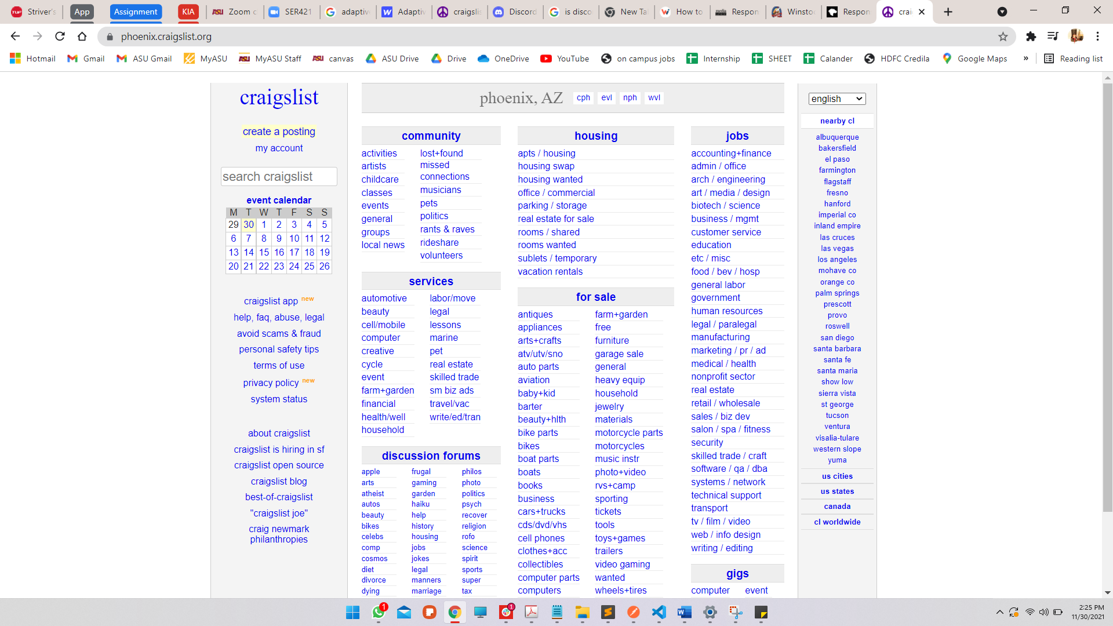

## No Effect on resizing

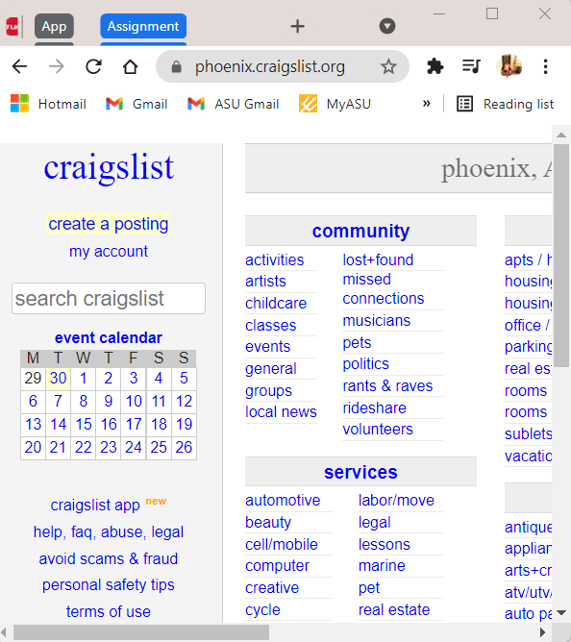

## Using developer settings, you can see a different mobile version showing up indicating a adaptive design.

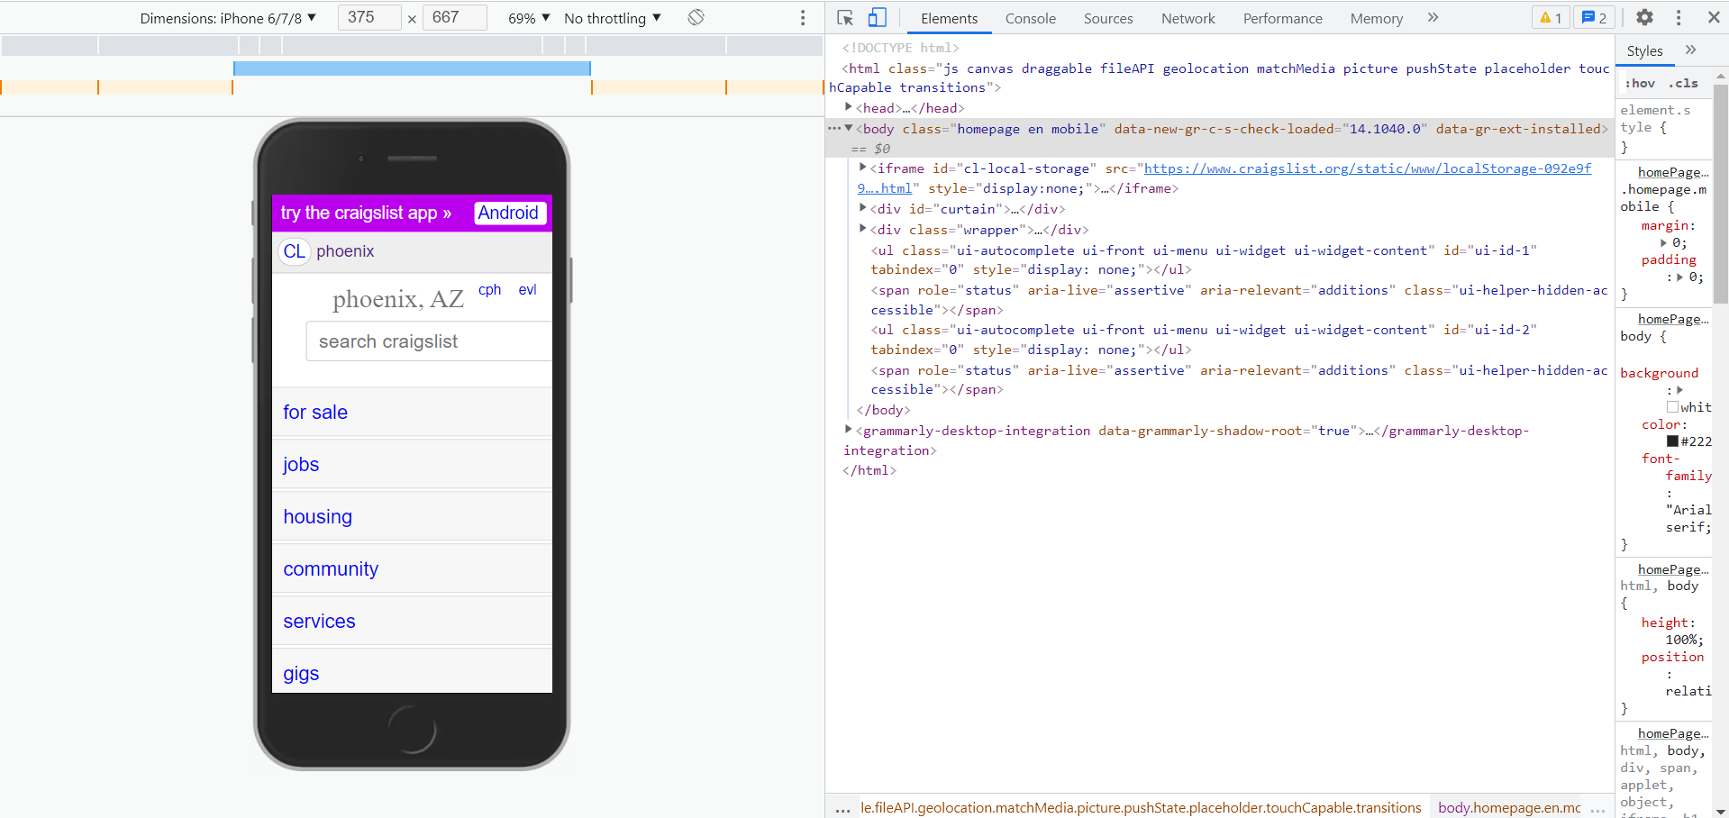

# 2. discord.com – Responsive

This website when opened on desktop presents a responsive design when resized. Even on the mobile device – it shows up similar website (not different html all together).

## Default View

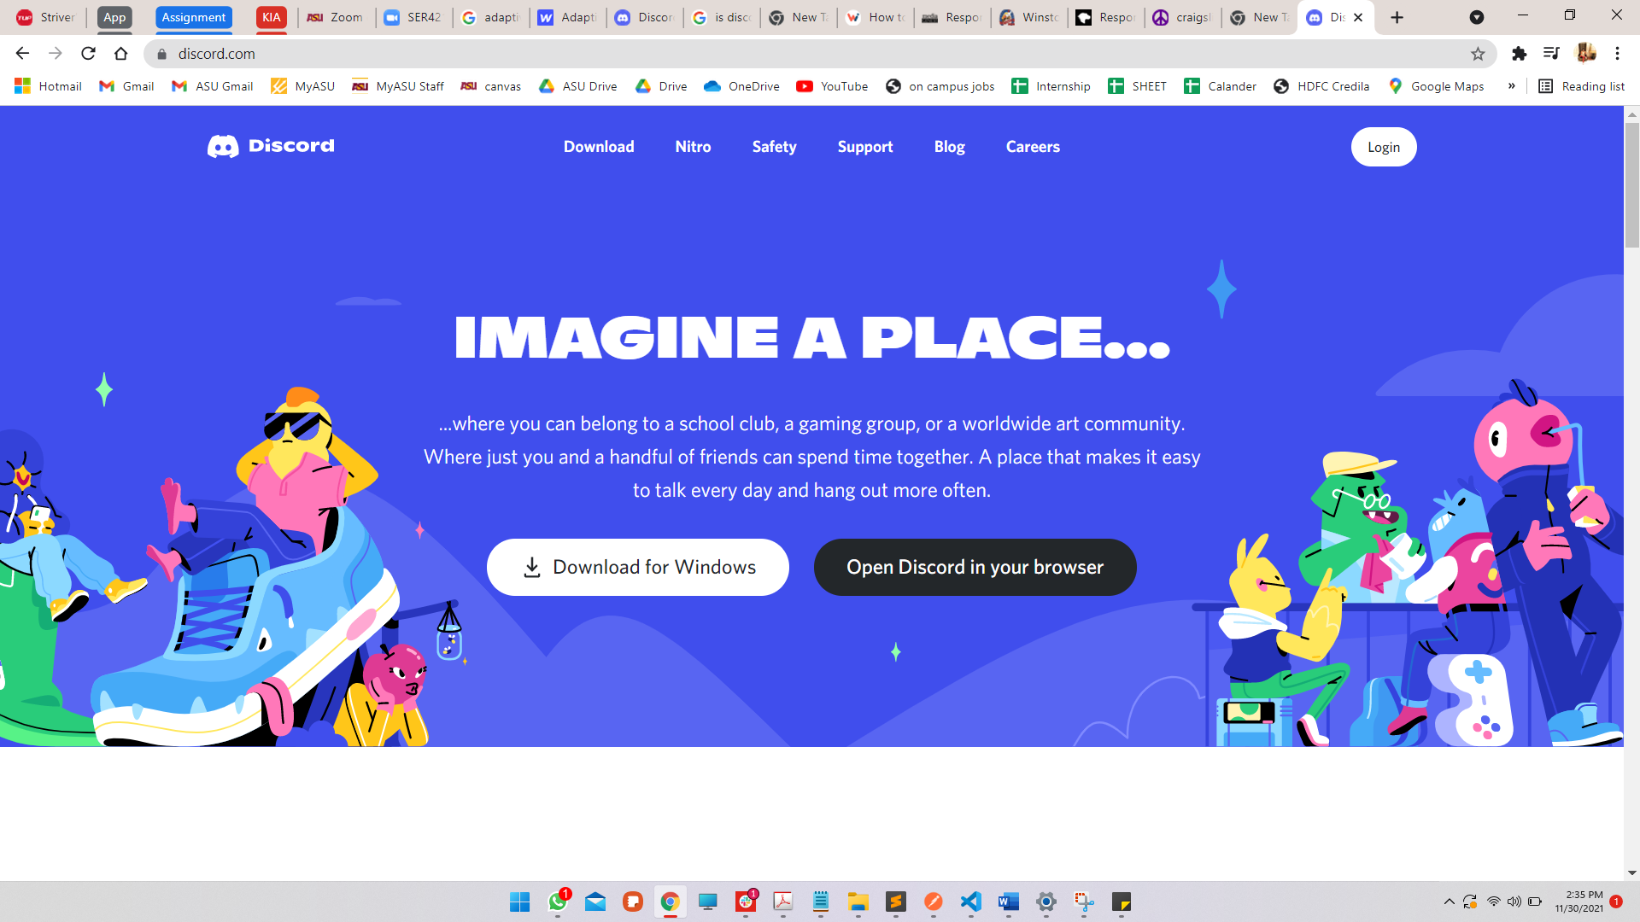

## Resizing:

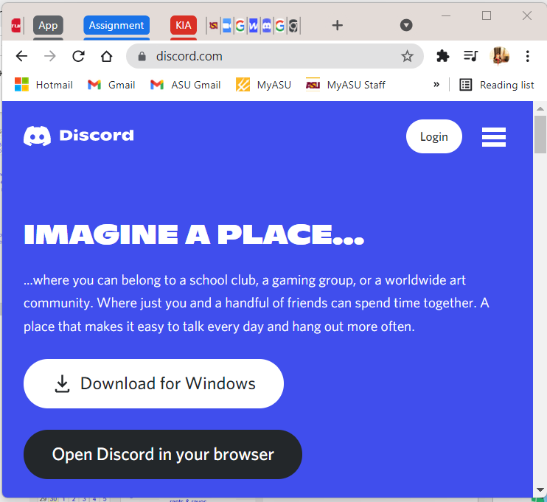

Mobile View:

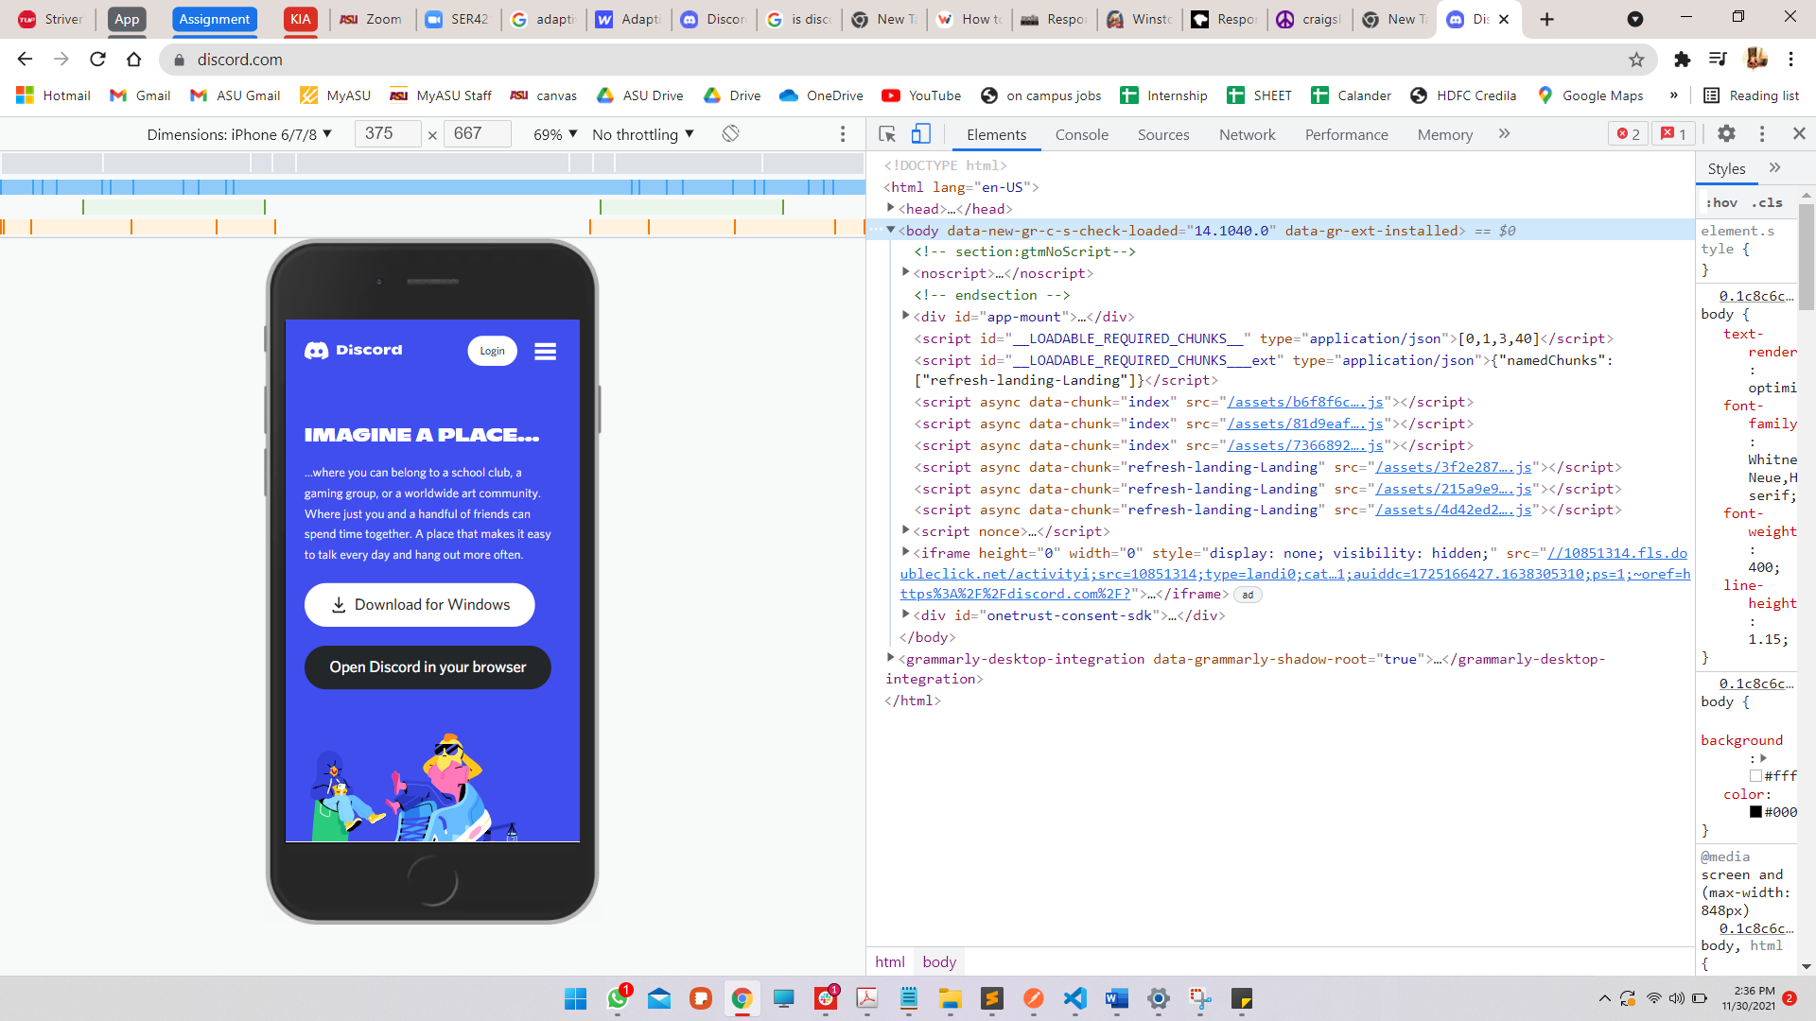

## 3. winstockfestival.com/ - Fluid & Responsive

When viewing the website on a desktop it resizes well with all elements changing size relative to the size of window. Also - responsive design is evident when the navigation bar changes to a hamburger menu.

## Default View



## Resizing changes all elements relative to the window

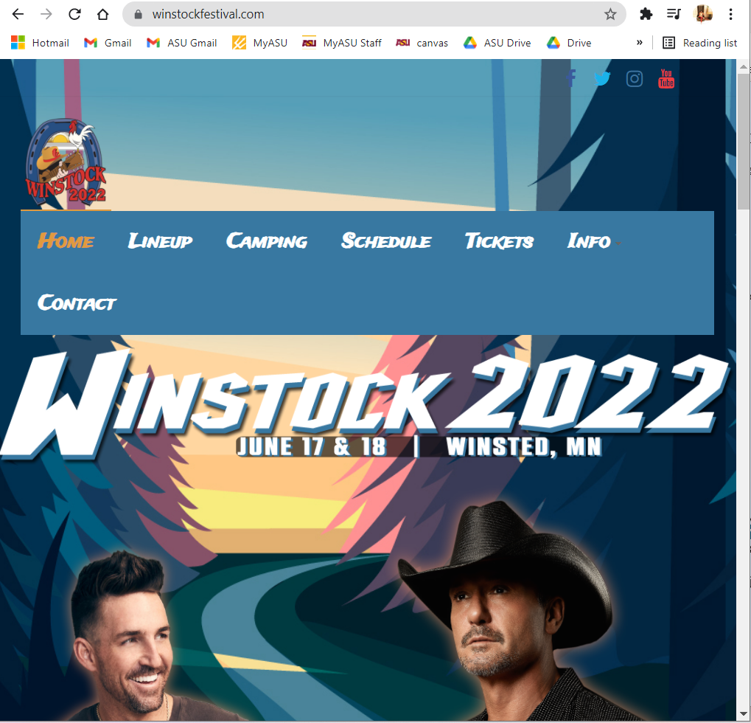

## Navigation Menu changed to Hamburger menu

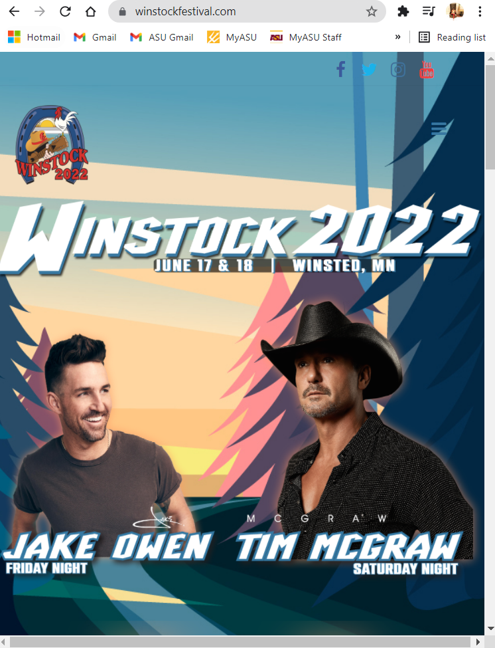

## Mobile View

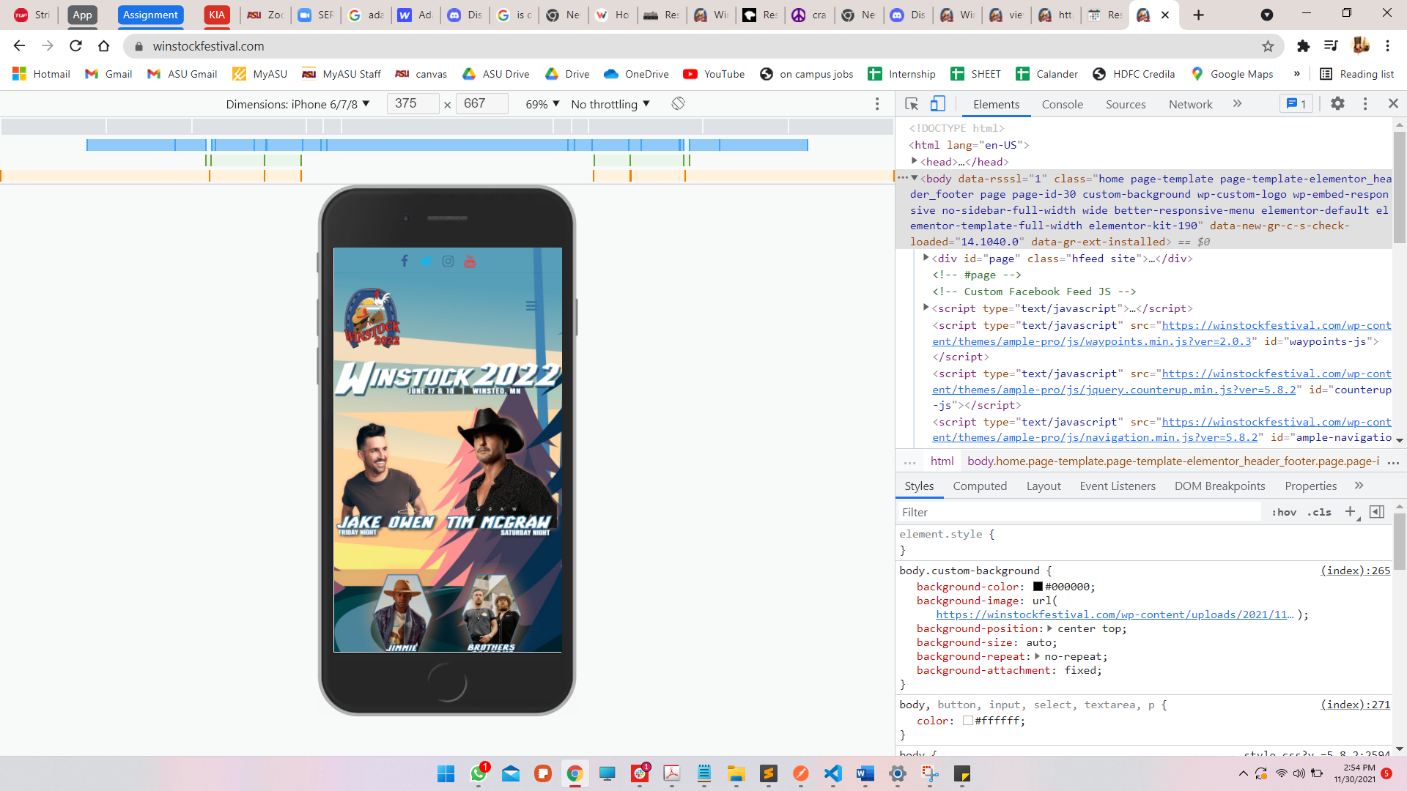

# 4. homedepot.com – Responsive & Fluid

When viewing the website on desktop it shows responsive design – when the browser window is shrinked, the navigation menu changes to a hamburger menu, the My Account, Lists, Cart buttons convert into icons. It shows fluid behavior when you shrink the website, and the Sponsored bar maintains it size and modifies width according to the window size.

## Default view

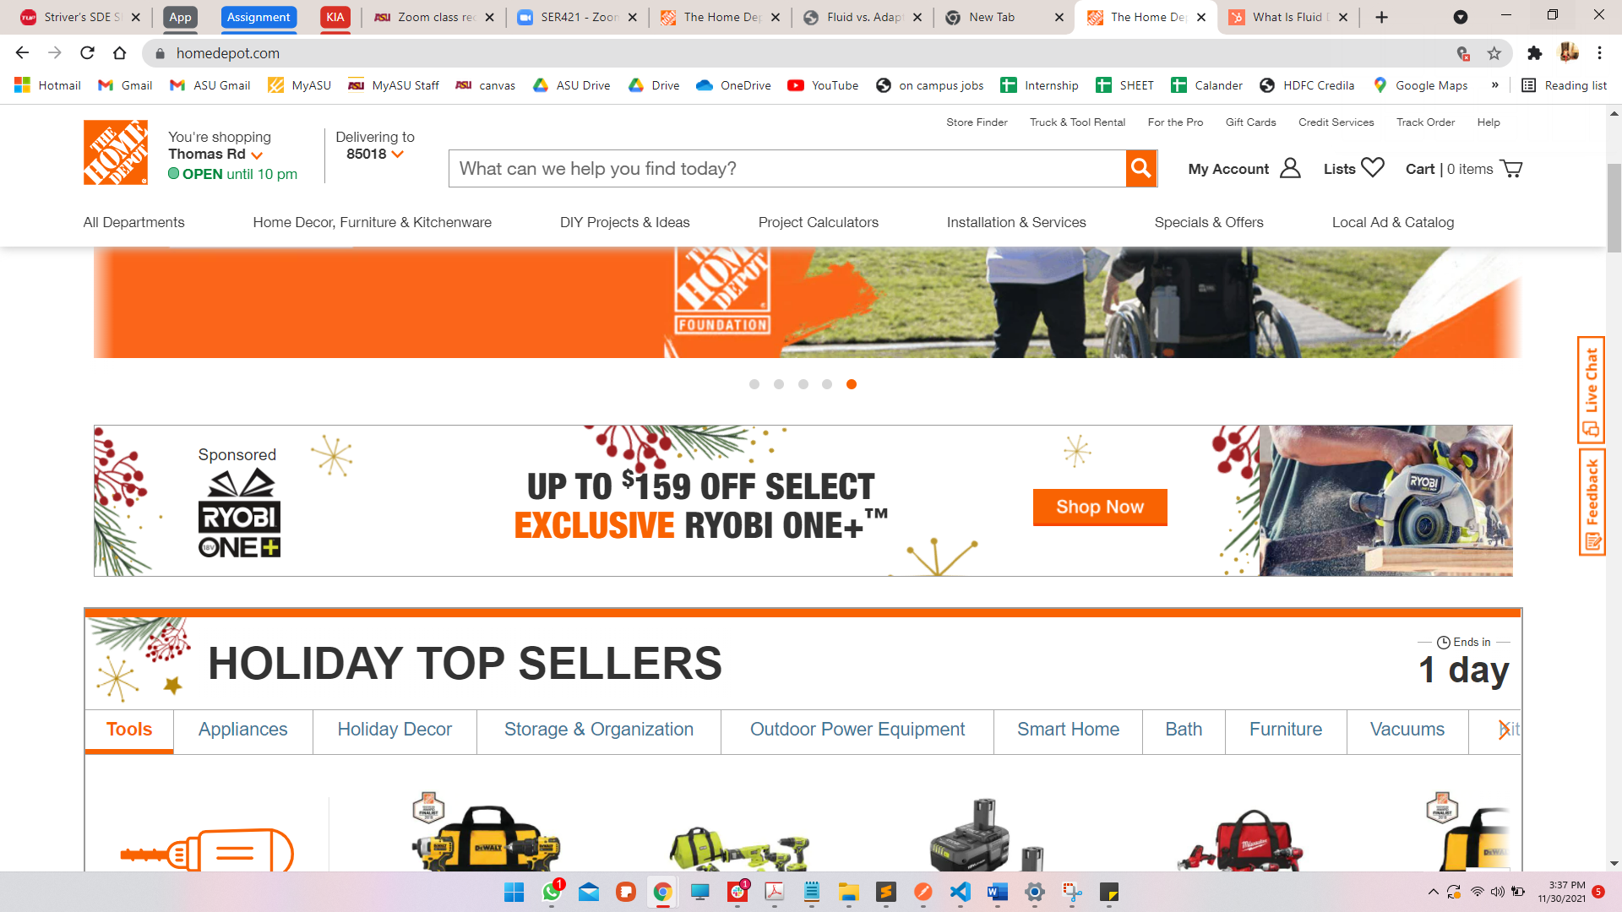

## Resizing changes nav bar to hamburger menu & buttons to icons

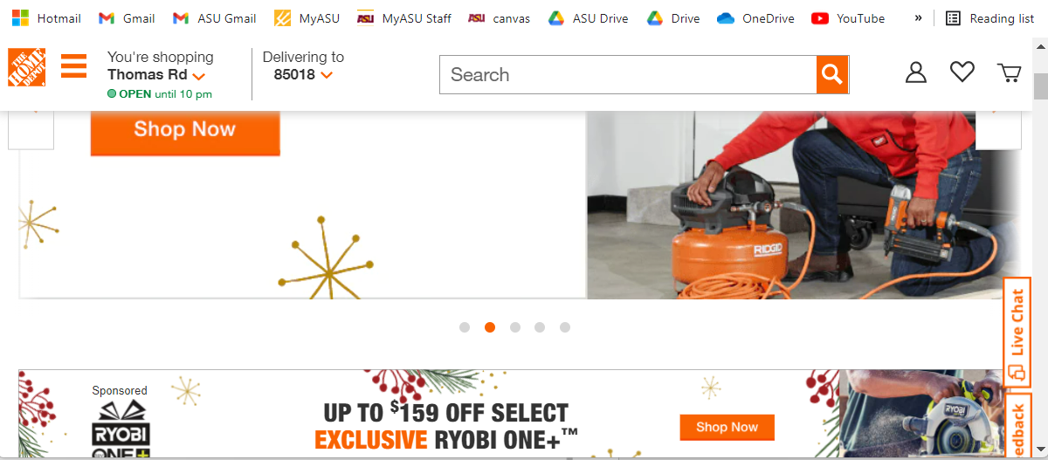

## The sponsor banner and other elements stay proportional to the width

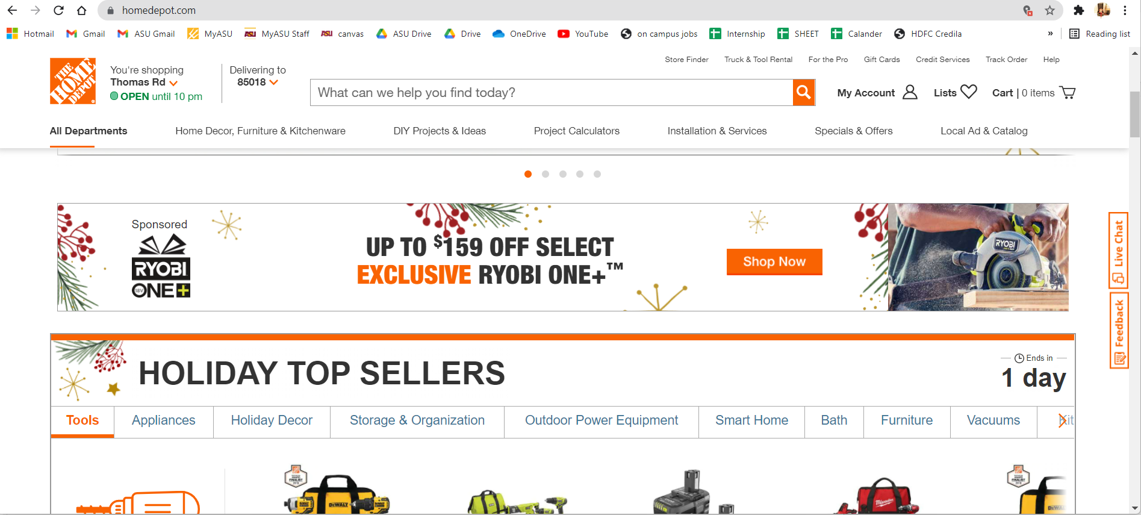

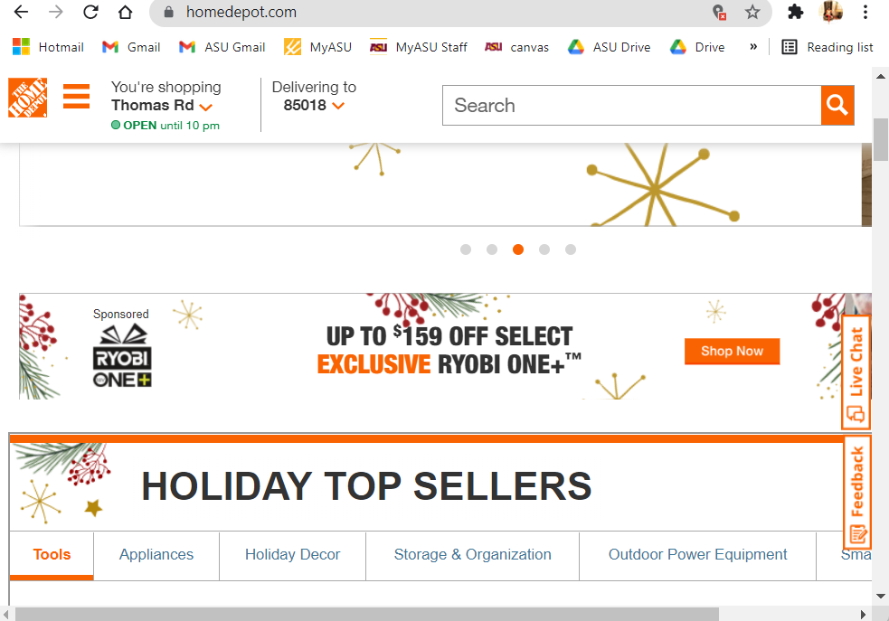

# 5. lowes.com – Responsive & Fluid

When opened in a desktop it shows a responsive design. When resized the Navigation menu changes to a hamburger menu and My List, Sign In, Cart convert into Icons. It also shows fluid behavior where the banners and product stay proportional to the width of the window.

## Default View

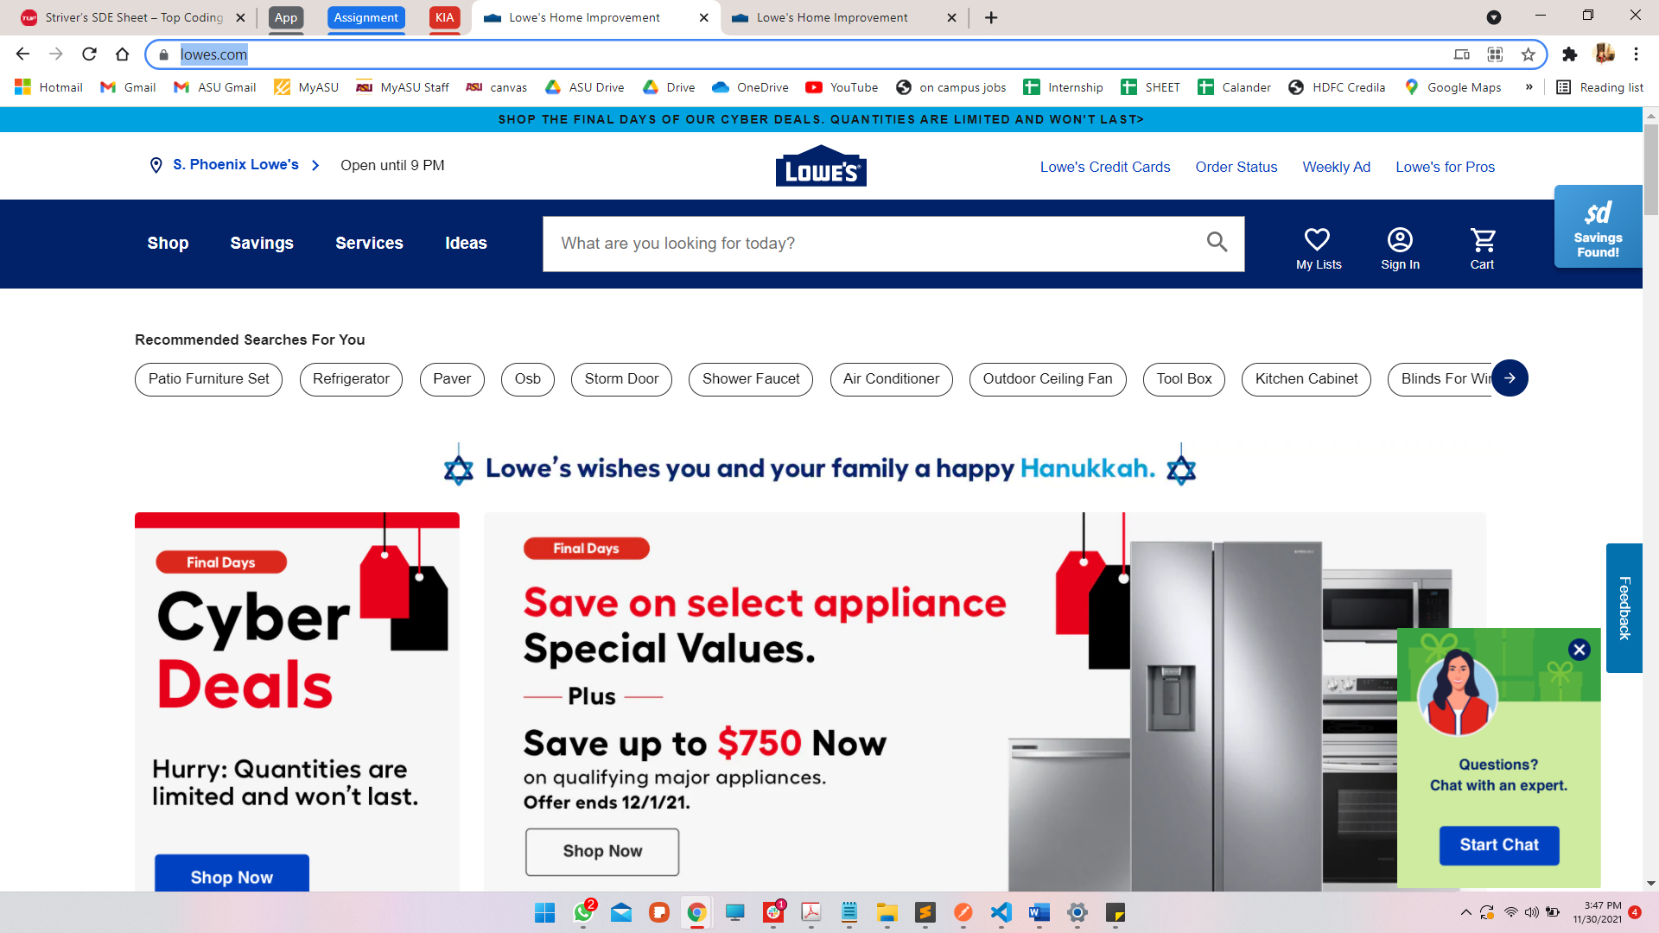

## Resized View

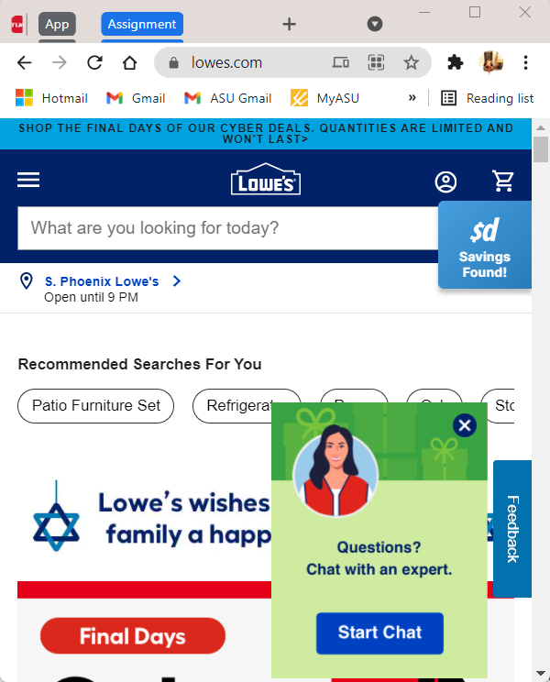

## Fluid: Banner resizing

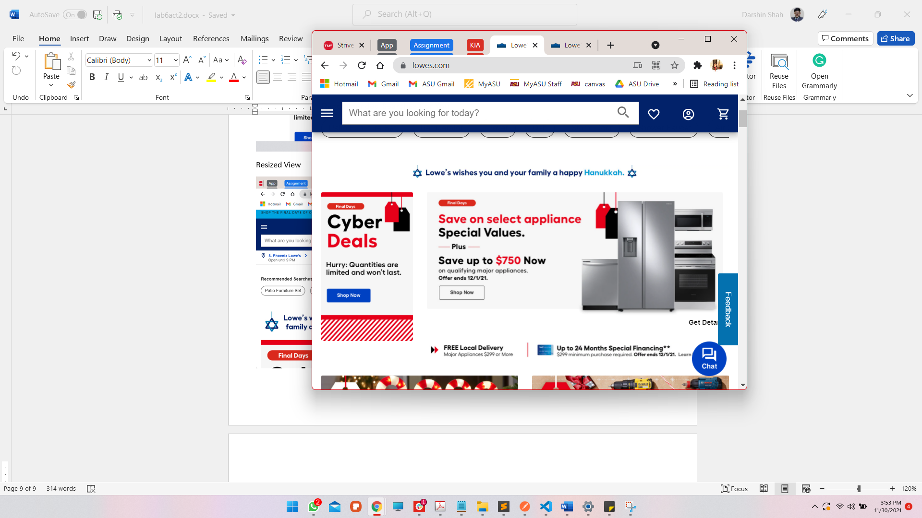 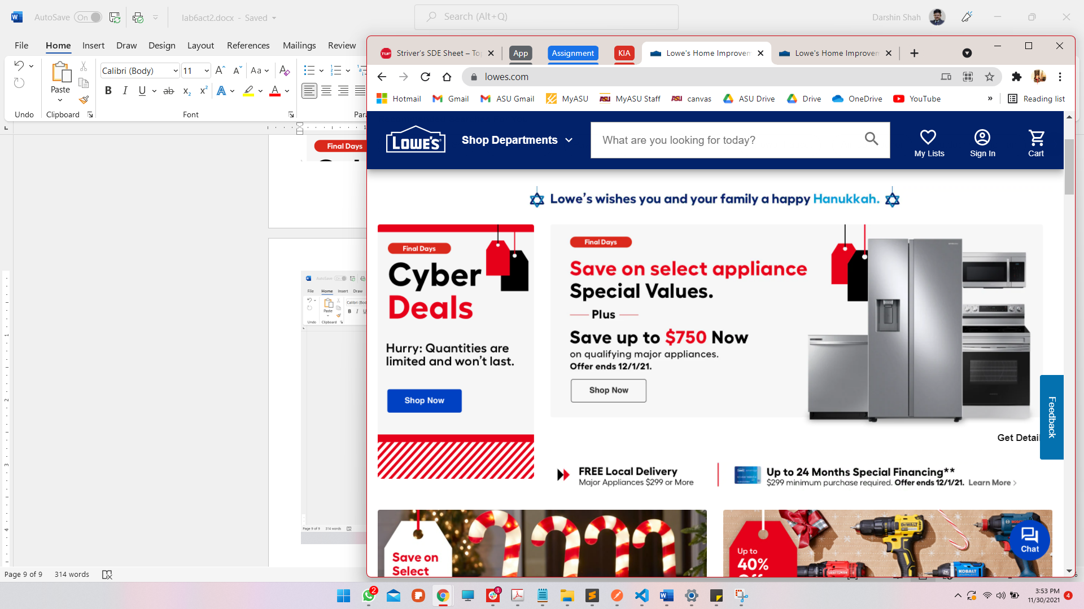

# PART 2

# Home Depot

## iPad

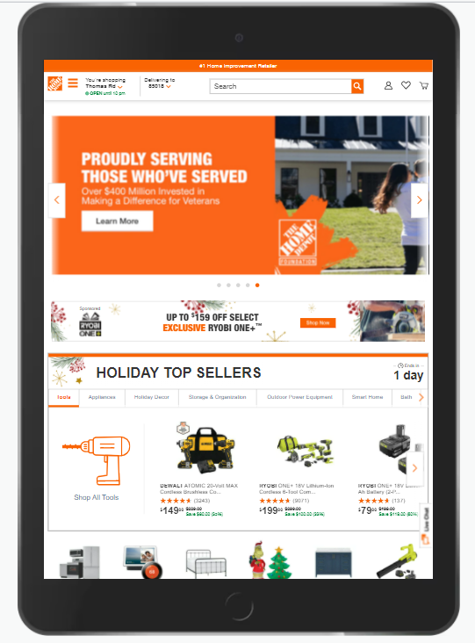

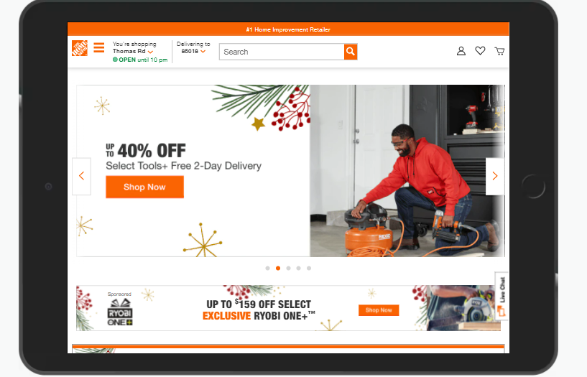

## Pixel 2XL

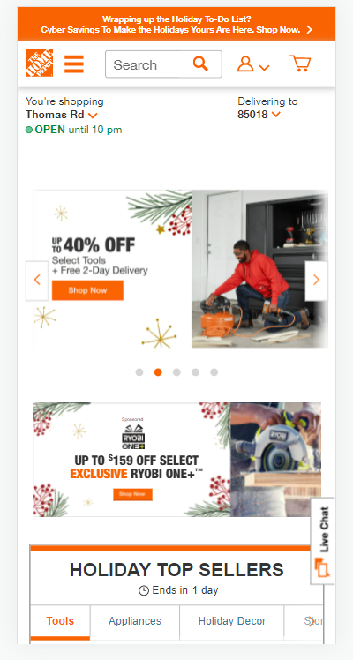

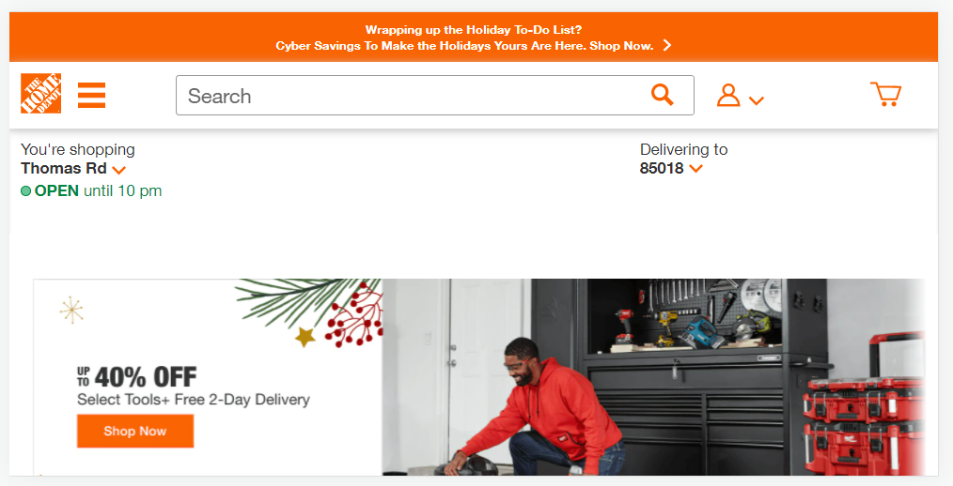

# Lowes

## iPad

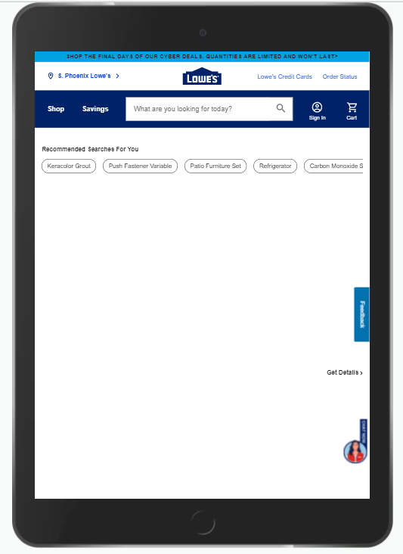

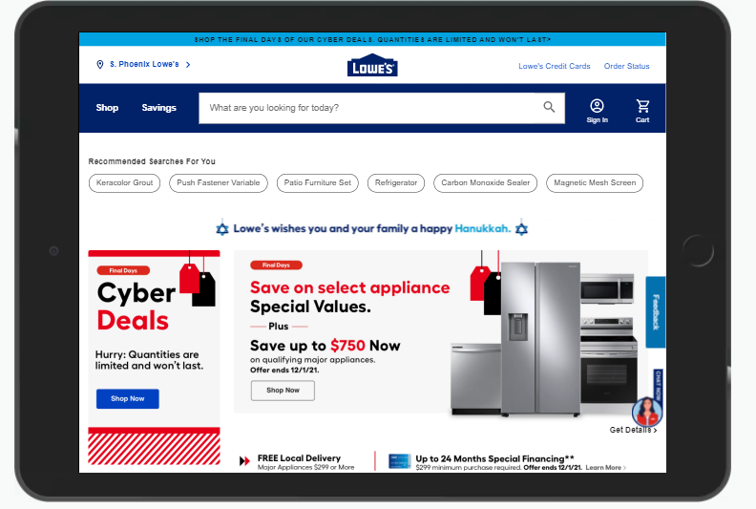

## Pixel 2XL

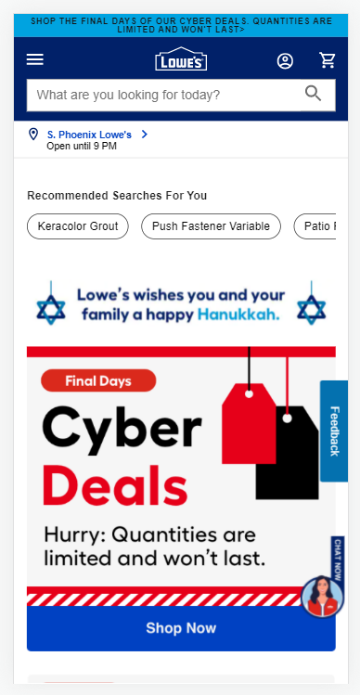

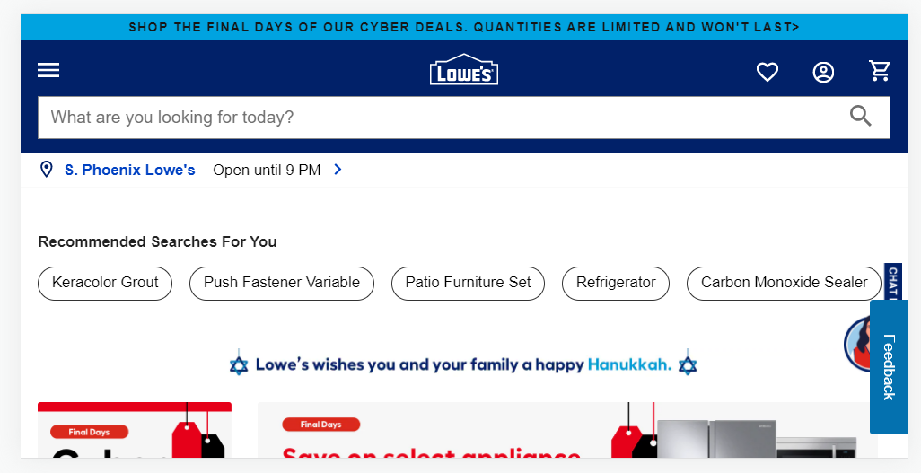

## Explanation:

The testing mode rightly corroborates with my findings. Both the websites scale and respond well to device changes and hence are Responsive and Fluid in design. For tablet (bigger devices) we can see that lowes.com shows the top bar with store name and in the smaller device – it shows as a different element. Banners for both the websites resize according to the avaliable width – even in the case of landscape and portrait mode. None of the banners get distorted when we change the page orientation.